Part 1:
Task 1.1:
1. Create variables for 2 more properties (property2, property3)
2. Calculate price per m² for all 3
For each of the three properties, we declare variables holding (name, price, area) and calculate price per square meter for each property.
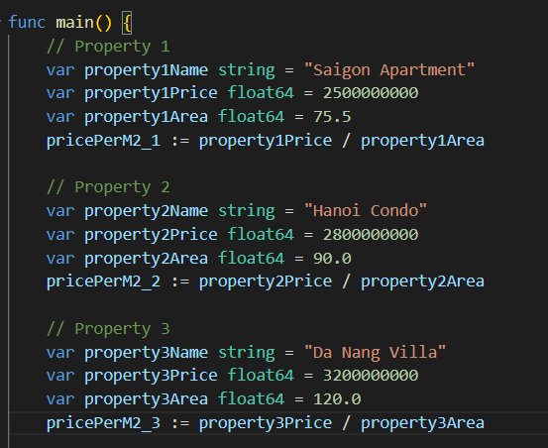
Prints the price per m² for all three properties.
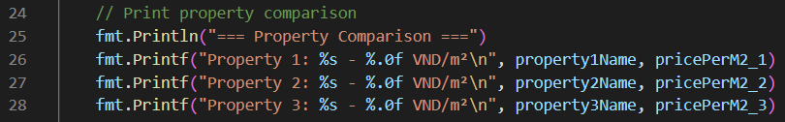

3. Find and print which property has the lowest price per m²
Uses slices to store property names and prices.
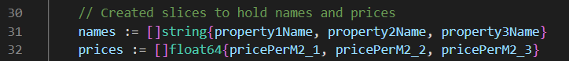
Loops through prices to find the cheapest property and prints the name and price of the cheapest property.
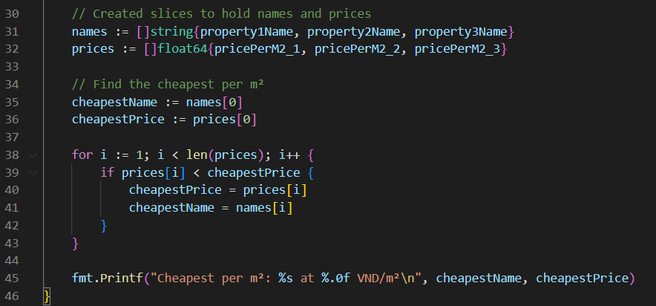
- Result:
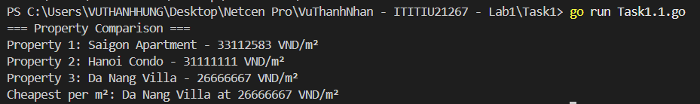

Task 1.2:
1. Use this function to categorize ALL your properties
We add Function that assigns a category based on price per m²:
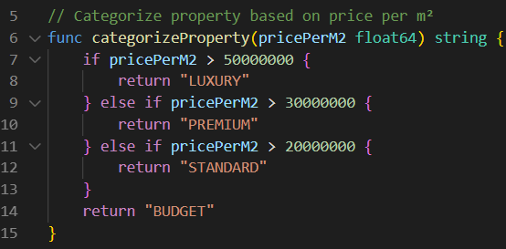
Calling categorizeProperty function to classify each category.
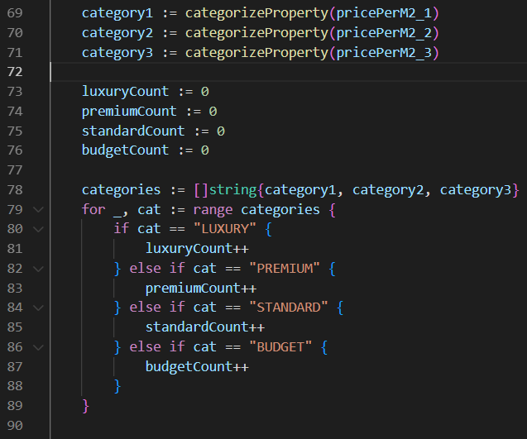
2. Count how many properties are in each category
Apply categorization to each property and count how many properties fall into each category.
3. Create a new function formatPrice() that converts VND to billions/millions
Convert large VND numbers to readable format:
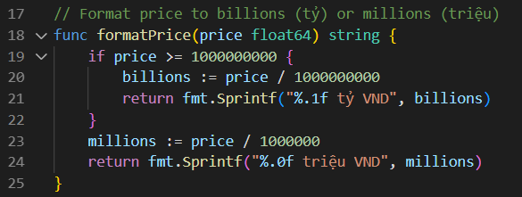
Display the result:
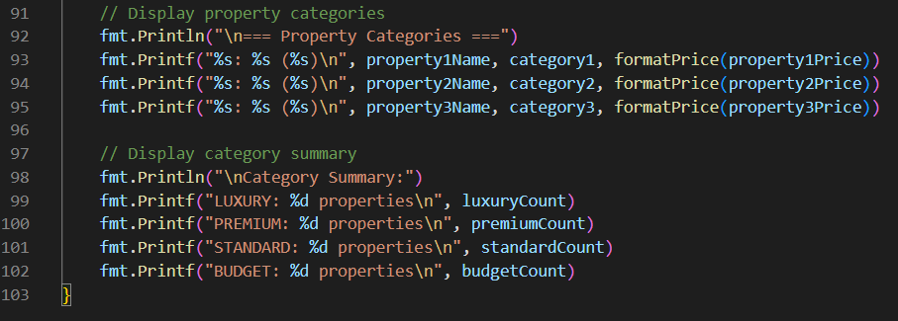
- Result:
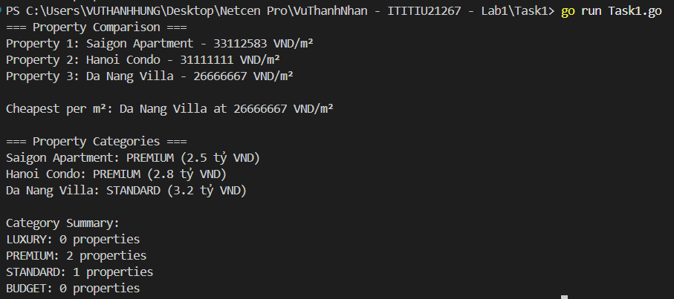

Part 2:
Property structure:
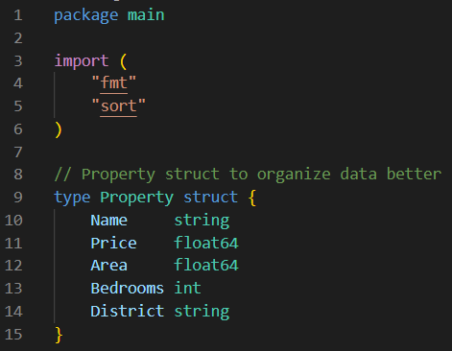
Sample properties:
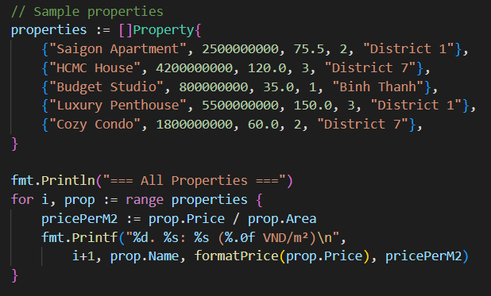

Task 2.1:
1. Function findPropertiesInBudget(properties []Property, maxBudget float64)
Implements a function that filters and returns all properties with prices less than or equal to a given maximum budget by iterating over the list and checking each price:
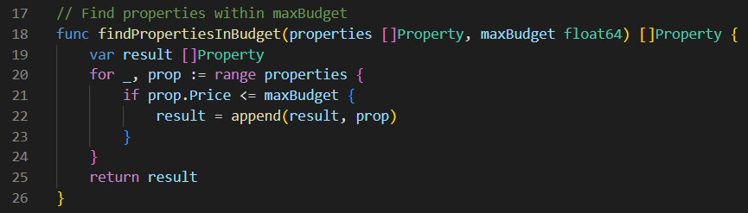
2. Function findPropertiesByBedrooms(properties []Property, bedrooms int)
Function that finds and returns properties matching an exact number of bedrooms by looping through all properties and comparing the bedroom count:
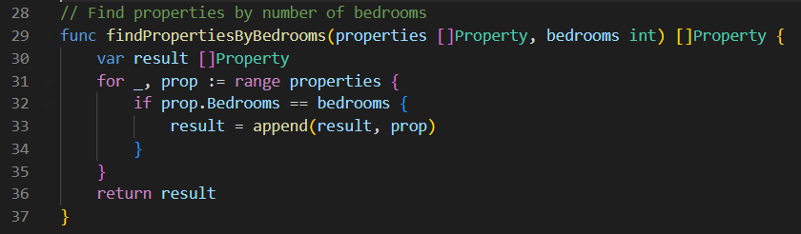
3. Test both functions with your data
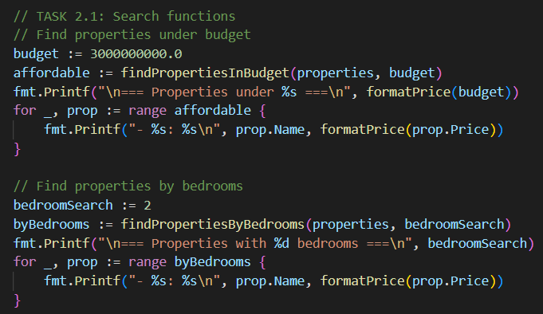
Result:
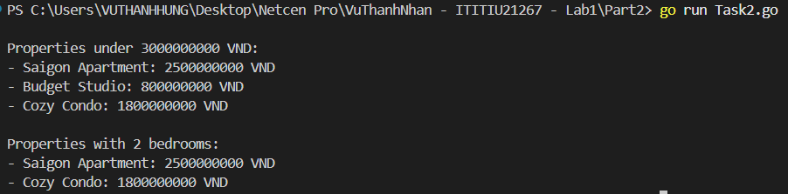

Defines a helper function to format property prices into readable strings, converting large values into billions or millions of Vietnamese Dong:
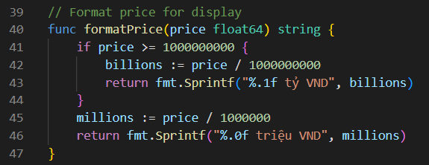
Task 2.2:
1. Use the analyzeByDistrict function
Groups properties by their district using a map where each key is a district name and the value is a list of properties in that district.
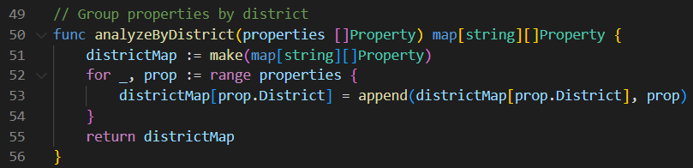
2. Create calculateDistrictStats() function that returns: - Average price per district - Property count per district - Most expensive property in each district
Introduces a DistrictStats struct to hold statistics:
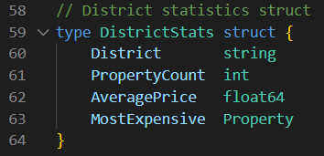
Calculates these statistics by iterating over each district's properties, summing prices, finding the highest price, computing the average, and returning the results as a slice of DistrictStats:
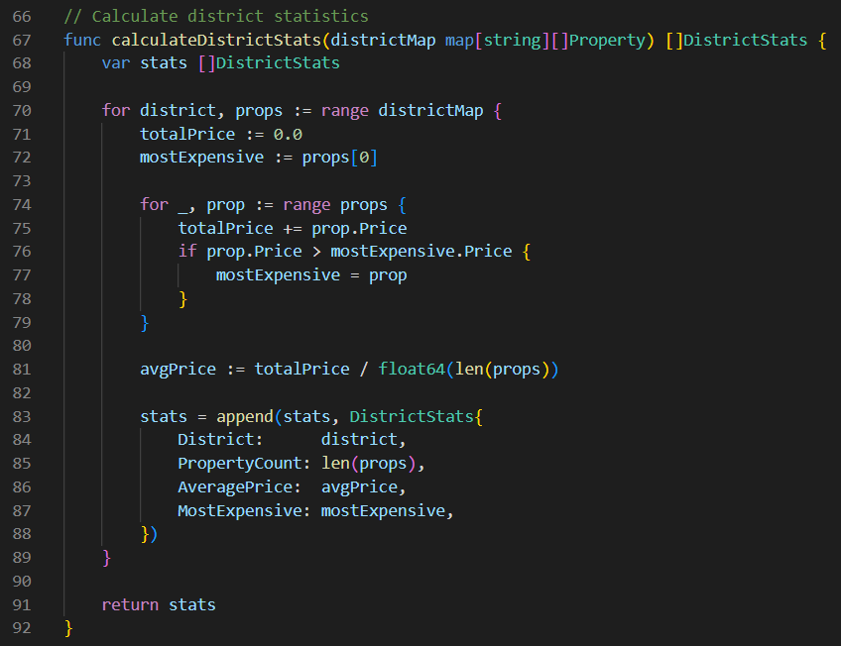
3. Display results sorted by average price (highest first)
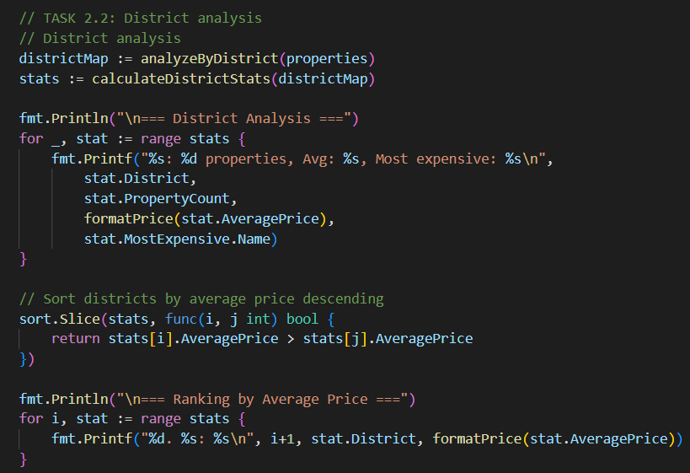
- Final result:
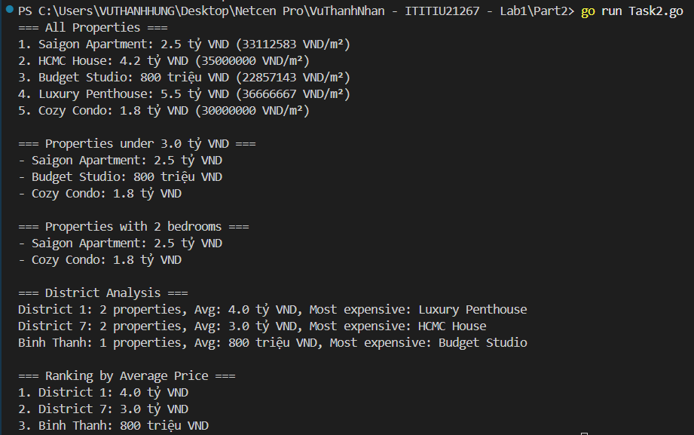

Part 3:
Task 3.1:
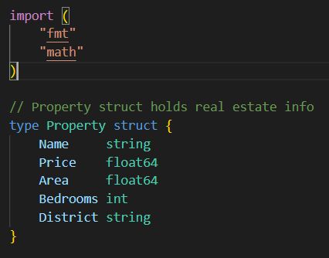
Property Methods:
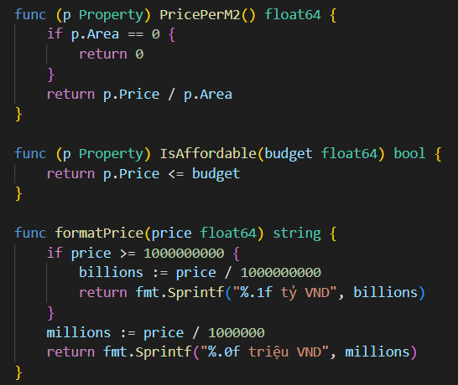
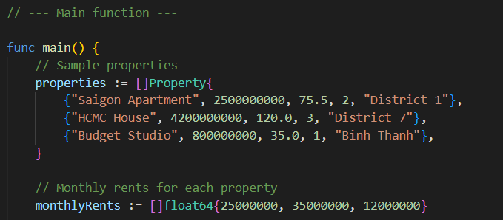
The CalculateROI method computes the annual return on investment as a percentage based on monthly rent and property price:
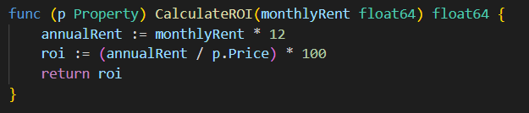
The InvestmentGradeWithRent method categorizes properties into investment quality tiers by comparing the ROI against predefined thresholds:
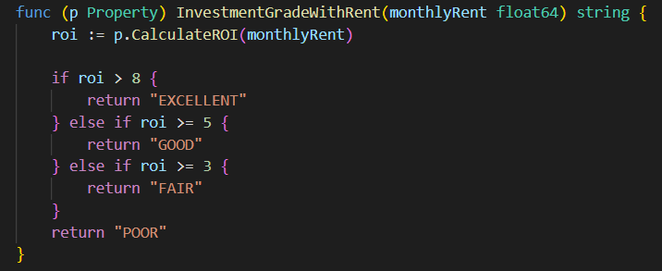
The findBestInvestment function iterates over properties and their rents to identify and return the property with the highest ROI:
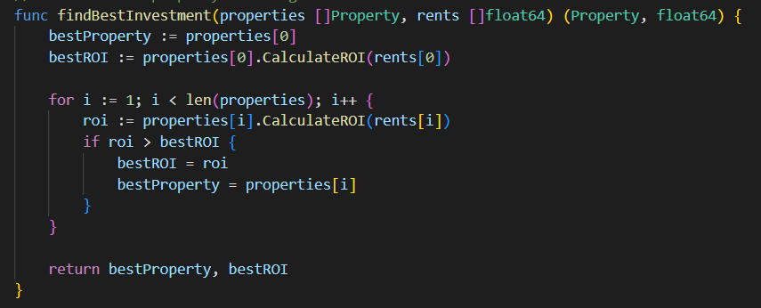
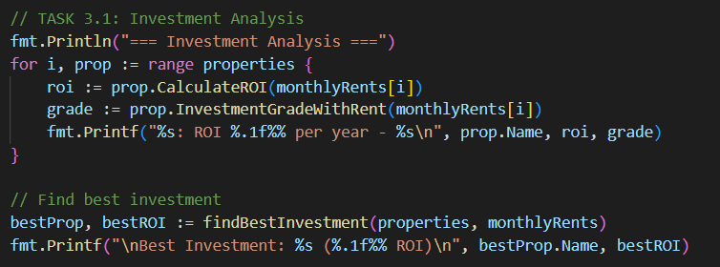
Result:
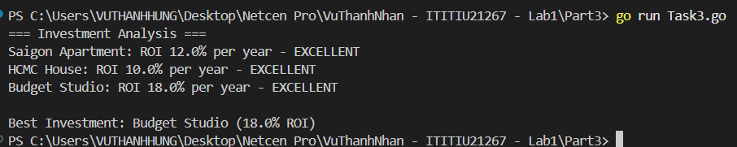

Task 3.2
The LoanInfo struct holds detailed loan results including loan amount, monthly payment, and total interest.
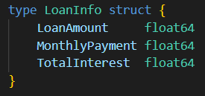
The calculateMonthlyPayment function uses the mortgage formula to compute monthly loan payments considering interest rate and loan duration.
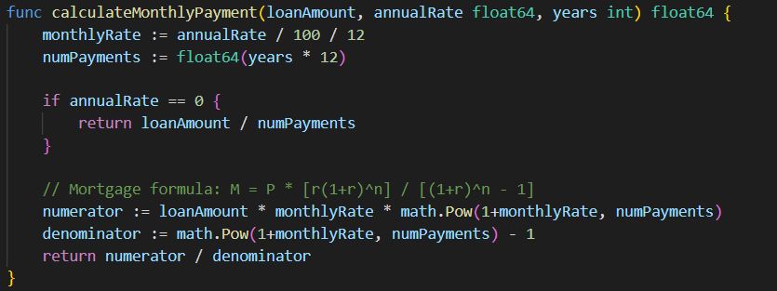
The CalculateLoan method calculates a property’s loan amount after down payment, monthly payments, and total interest over the loan period.
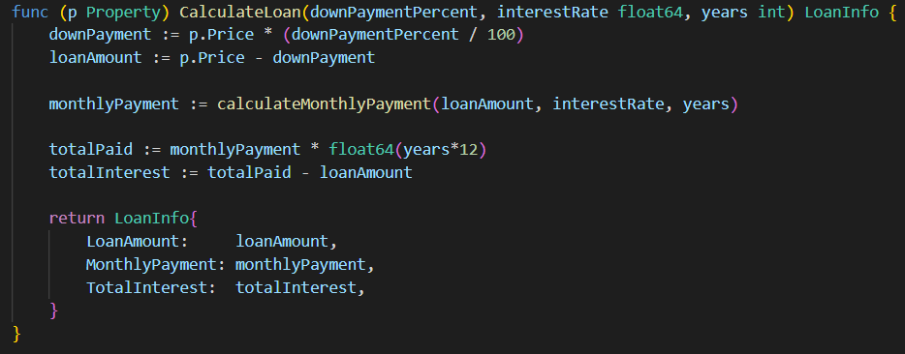
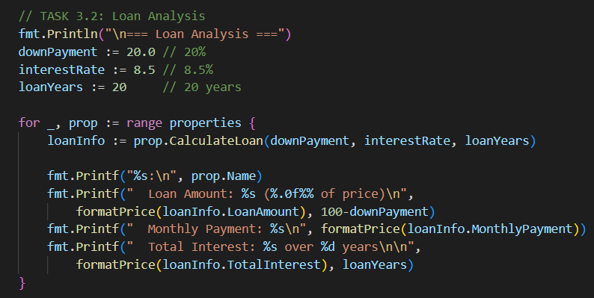
- Final result: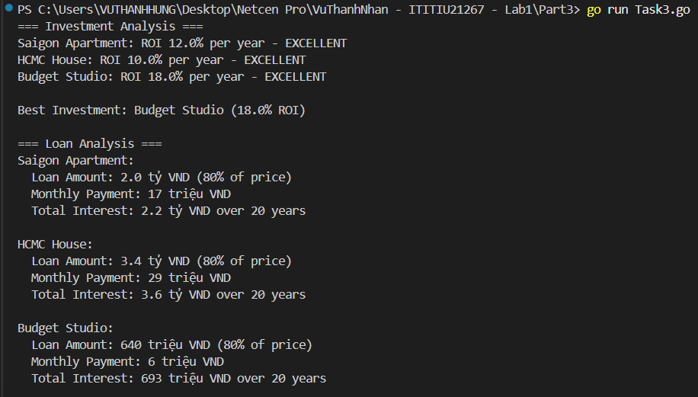

Part 4:
- Final result:
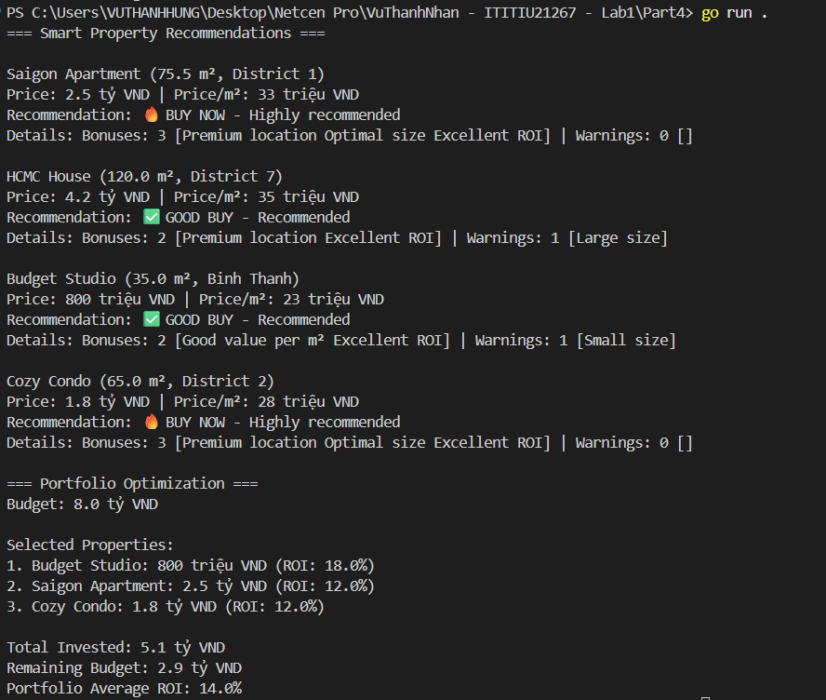

Part 5:
Property Analyzer Menu:
